**Lab Work-2**

Jaedon Teel

CS-3423-01: Mobile/Web Applications

February 5, 2023

**GitHub Link to your Web-App/Lab-2 repository:**

<https://github.com/TheDev24752/Web-App-Lab-2>

**Output Screenshots:**

**Problem-01: Calculator**

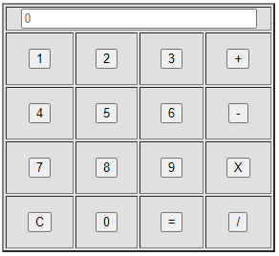

The application opens to a calculator with nothing in the text box besides the placeholder “0”.

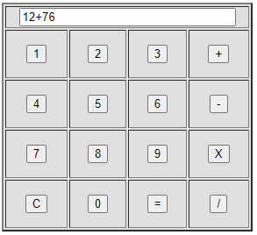

The user enters a simple equation with the buttons

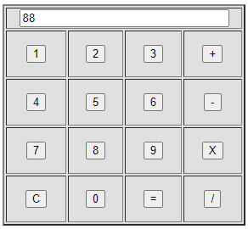

After pressing the “=” button, the calculator parses the input and outputs the result.

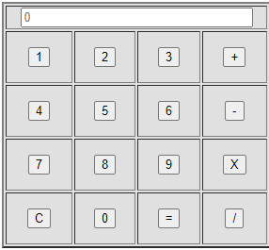

When the “C” button is pressed, the textbox is cleared

**Problem-02: Word Game**

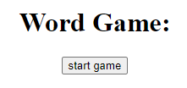

When the game is opened, the user is greeted with the start screen

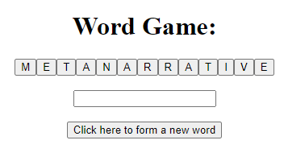

After pressing the “start game” button, the user sees the game screen

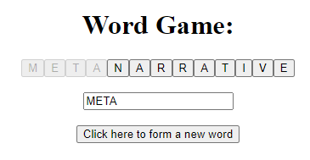

When the user presses the letter buttons, they are greyed out and the letter appears in the box

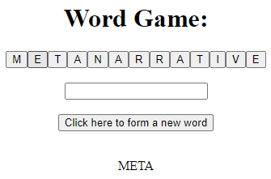

When the user presses the “Click here to…” button, the letters are reenabled, and the word appears at the bottom of the screen

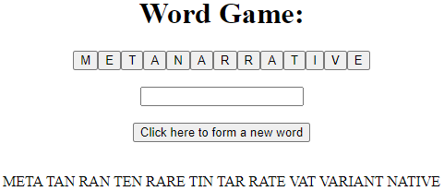

After a few words, the game will look like this